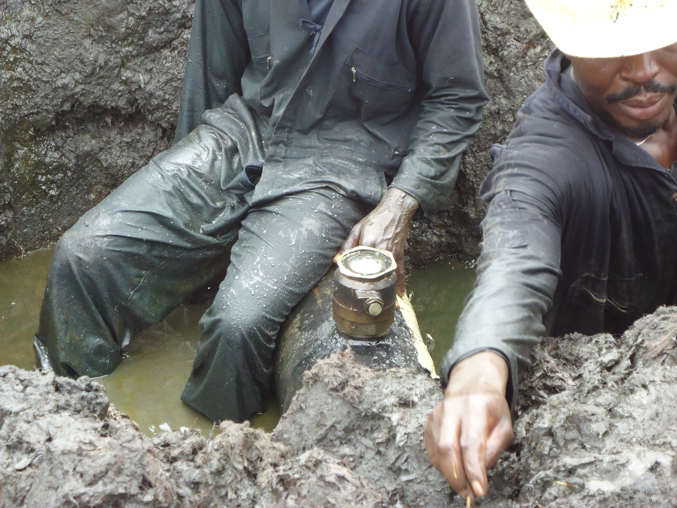
Pix showing spill Point during jiv.

